**Chapter 4:**

Horizontal Rule Element:

Configures a horizontal line.

<hr>



CSS Border Property:

Configures a border on the top, right, bottom, and left sides of an element.

Consists of:

Border-width

Border-style

Border-color

Example:

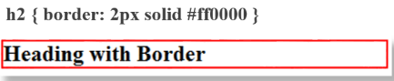

CSS Borders - Block/Inline Elements:

Block display element

Default width of element content extends to browser margin (or specified width).

Inline display element

Border closely outlines the element content.

Example:

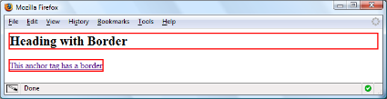

https://lh3.googleusercontent.com/_1LJWQyXThvCpO_VI8ei4L91Wuc_44pfzQoV7fpLHM30jC-9D_ax1R2mLo1D5TO-xGw76uxiwAYbiJGoForedqQSfIAvBeC2KqBqSr_QwYiwuZzPsYE_wCC5G_ctuqtW6GxqeI0

Browser Display Can Vary

Configuring Specific Sides of a Border:

Use CSS to configure a line on one more sides of an element.

Border-bottom

Border-left

Border-right

Border-top

https://lh4.googleusercontent.com/JWiqs0jsBvBwdmofMm_szUQGz9jBsYOBc1zrqzHmJC7veDBHbJuoIp6st11BKOKk4gjgMKjU0Iv16bkSoMipnJgyOuhfiLGXofkSPHJFvHGM6Kd77ErC8GJXGIiv9JBtlp37SuA

CSS Padding Property:

Configures empty space between the content of the HTML element and the border.

Set to 0px by default.

https://lh6.googleusercontent.com/TTXJJQE3Ai-1Rx2F3wTcSD8Nlo-Ghn57JoF9X4dqh0n_vWOYfdQZaPkOudEEY2iCLNZpIbNtVv6tsNbievfkn5SPfXmcWB9NSRSvWbrIUFVbzg1nERaXFEiLO7Dd3bt-hnHwBv0

No padding property configured:

https://lh6.googleusercontent.com/IlXm1Ldsjne3RaRakfEOeKNQfDBn513WobLtdp_9ru3TBWMG4R_jPy9B_DMrCq2xdSdujDTLm4EhSlYMjjoxPsz7WzKPD6rGUvJT-U1uSyJ5heGjZ0b1wlabaLjNtcM0xJmtxas

Configure Padding on Specific Sides:

Use CSS to configure padding on one or more sides of an element.

Padding-bottom

Padding-left

Padding-right

Padding-top

CSS Padding Property Shorthand - Two Values:

Two numeric values or percentages.

First value configures top and bottom padding.

The second value configures left and right padding.

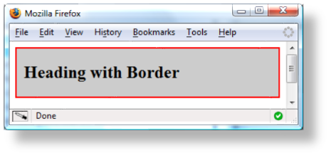

h2 {border: 2px solid #ff0000;  
background-color: #cccccc;

padding: 20px 10px; }

CSS Padding Property Shorthand - Four Values:

Four numeric values or percentages.

Configure top, right, bottom, and left padding.

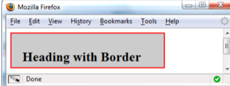

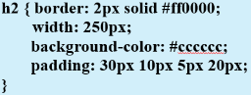

Types of Graphic:

Graphics types commonly used on web pages:

GIF

JPG

PNG

GIF:

Graphics Interchange Format.

Best used for line art and logos.

Maximum of 256 colors.

One color can be configured as transparent.

Can be animated.

Uses lossless compression.

Can be interlaced.

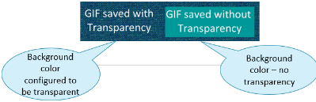

JPEG:

Joint Photographic Experts Group.

Best used for photographs.

Up to 16.7 million colors.

Use lossy compression.

Cannot be animated.

Cannot be transparent.

Progressive JPEG - similar to interlaced display.

PNG:

Portable Network Graphic.

Support millions of colors.

Support multiple levels of transparency.

but most browsers do not → so limit to one transparent color for Web display.

Support interlacing.

Use of lossless compression.

Combines the best of GIF and JPEG.

Browser support is growing.

HTML Image Element:

Configures graphics on a web page.

<img src=”dog.jpg” alt=”Dog at computer” height=”100” width=”100”>

src Attribute

File name of the graphic.

alt Attribute

Configures alternate text description.

height Attribute

Height of the graphic in pixels.

width Attribute

Width of the graphic in pixels.

Accessibility & Images:

Required:

Configure the alt attribute.

Alternate text content to convey the meaning/intent of the image.

NOT the file name of the image.

Use alt=”” for purely decorative images.

Recommended:

If your site navigation uses image links for the main navigation, provide simple text links at the bottom of the page.

Image Link:

To create an image hyperlink use an anchor element to contain an image element.

<a href =”index.html”><img src=”home.gif” height=”19” width=”85” alt=”Home”></a>

Some browsers automatically add a border to image links.

Configure CSS to eliminate the border:

img {border-style: none; }

Thumbnail Image:

A small image configured to link to a larger version of that image.

<a href=”big.jpg”><img src=”small.jpg” alt=”country road” width=”200”height=”100”></a>

Image Optimization:

The process of creating an image with the lowest file size that still renders a good quality image - **balancing image quality and file size**.

Photographs taken with digital cameras are not usually optimized for the Web.

Optimize an Image for the Web:

Image Optimization:

Reduce the file size of the image.

Reduce the dimensions of the image to the actual width and height of the image of the web page.

Image Editing Tools:

GIMP (free!)

Adobe Fireworks

Adobe Photoshop

Choosing Names for Image Files:

Use all lowercase letters.

Do not use punctuation symbols and spaces.

Do not change the file extensions.

(should be .gif, .jpg, .jpeg, or .png)

Keep your file names short but descriptive.

Organizing Your Site:

Place your image in their own folder.

Code the path to the file in the src attribute.

<img src=”images/home.gif” alt=”Home” height=”100” width=”200”>

HTML5 Figure and Figcaption Elements:

Figure Element: contains a unit of content that is self-contained, such as an image,along with one optional figcaption element.

<figure>  
<img src=”lighthouseisland.jpg” width=”250” height=”355” alt=”Lighthouse Island”>   
<figcaption> Island Lighthouse, Built in 1870 </figcaption>  
</figure>

HTML5 Meter Element:

Displays a visual gauge of a numeric value within a known range.

<meter value="14417" min="0" max="14417">14417</meter>14,417 Total Visits<br>

HTML5 Progress Element:

Displays a bar that depicts a numeric value within a specified range.

<progress value=”5000” max=”10000>5000</progress> Progress Towards Our Goal.

CSS Background-Image Property:

Configures a background-image.

By default, background images tile (repeat)

body {background-image: url(background.gif); }

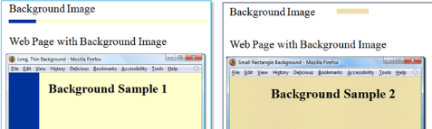

CSS Background-Repeat Property:

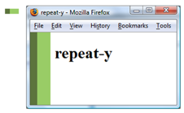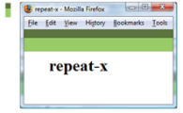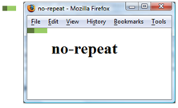

Image Map:

map element:

Defines the map.

area element:

Defines a specific area on a map.

Can be set to a rectangle, circle, or polygon.

href Attribute

shape Attribute

coords Attribute

Favorites Icon – favicon:

A square image associated with a web   
page.

Usually named: favicon.ico

May display in the browser address bar, tab, or favorites/bookmarks list

Configure with a link tag:

**<link rel="icon" href="favicon.ico" type="image/x-icon">**

CSS Sprites:

Sprite – an image file that contains multiple small graphics that are configured as background images for various web page elements.

Modern technique to optimize use of multiple icon or small images

Saves overhead by reducing the number of http requests made by the browser.

Guidelines for Using Images:

Reuse images.

Consider image file size with image quality.

Consider image load time.

Use appropriate resolution.

Specify dimensions.

Be aware of brightness and contrast.

Images and Accessibility:

**Don't rely on color alone.**

Some visitors may have color perception deficiencies. Use high contrast between background and text color.

**Provide a text equivalent for non-text elements.**

Use the alt attribute on your image elements

**If your site navigation uses image links, provide simple text links at the bottom of the page**.

CSS Rounded Corners:

border-radius property:

Configures the horizontal radius and vertical radius of the corner

Numeric value(s) with unit (pixel or em) or percentage

Example

h1 { border-radius: 15px; }

CSS3 box-shadow Property:

Configure the horizontal offset, vertical offset, blur radius, and valid color value

Example: #wrapper { box-shadow: 5px 5px 5px #828282; }

CSS3 opacity Property:

Configure the opacity of the element

Opacity range:

0 Completely Transparent

1 Completely Opaque horizontal offset, vertical offset, blur radius, and valid color value.

Example:

h1{ background-color: #FFFFFF; opacity: 0.6; }

CSS3 Gradients:

Gradient: a smooth blending of shades from one color to another

Use the background-image property

linear-gradient()

radial-gradient()

Example:

body { background-color: #8FA5CE; background-image: linear-gradient(#FFFFFF, #8FA5CE); }